A
MINOR PROJECT REPORT
on
ZIGBEE BASED NEARBY VEHICLE ACCIDENT ALERT SYSTEM
Submitted in partial fulfillment of the Requirements for the award of Degree
of
Bachelor of Technology
in
ELECTRONICS &COMMUNICATION ENGINEERING
By

K.RAJU - 22681A0433

under the esteemed guidance of
Mr. K. Amarender
M.TECH
Assistant professor

CHRISTU JYOTHI INSTITUTE OF TECHNOLOGY AND SCIENCE
Colombo Nagar, Yeshwanthpur, Jangaon, TS 506167, Telangana
Department of Electronics & Communication Engineering
(Accredited by National Board of Accreditation)
2024-2025

CHRISTU JYOTHI INSTITUTE OF TECHNOLOGY & SCIENCE
(Affiliated to JNTU, Hyderabad)
Colombonagar, Yeshwanthapur, Jangaon Dist. 506167, Telangana.
Dept. Electronics & Communication Engineering
2024-2025

CERTIFICATE
This is to certify that the work which is being presented in the B. Tech. Mini Project Report entitled “ZIGBEE BASED NEARBY VEHICLE ACCIDENT ALERT SYSTEM” being submitted by 22681A0433 (K. RAJU), impartial fulfillment of the requirements for the award of the Bachelor of Technology in “Electronics & Communication Engineering” and submitted to the Department of Electronics & Communication Engineering of Christu Jyothi Institute of Technology and Science, Jangaon.
This is to certify that the above statement made by the candidate is correct to the best of my knowledge

Signature of Guide Signature of HOD
Mr. K. Amarender Mr. ALLANKI SANYASI RAO
ASSISTANT PROFESSOR ASSOCIATE PROFESSOR

Signature of External Examiner

CHRISTU JYOTHI INSTITUTE OF TECHNOLOGY & SCIENCE
(Affiliated to JNTU, Hyderabad)
Colombonagar, Yeshwanthapur Jangaon Dist

Institute Vision and Mission
Vision
To admit and groom students from rural background and be a truly rural technical institution, benefiting society and nation as a whole institute.
Mission
- The mission of the institution is to create, deliver and refine knowledge. Being a rural technical institute, our mission is to.
- Enhance our position to one of the best technical institutions and to measure our performance against the highest defined standards.
- Provide highest quality learning environment to our students for their greater well-being so as to equip them with highest technical and professional ethics.
- Produce engineering graduates fully equipped to meet the ever-growing needs of industry and society

PRINCIPAL

CHRISTU JYOTHI INSTITUTE OF TECHNOLOGY & SCIENCE
(Affiliated to JNTU, Hyderabad)

DEPARTMENT OF ELECTRONICS & COMMUNICATION ENGINEERING

VISION
To be an established center of excellence in Electronics and Communication Engineering facilitating youth towards professional, leadership and industrial needs.
MISSION
- Impart theoretical and practical technical education of high standard with quality resources and collaborations.
- Organize training's and activities towards Overall personality development in time with industrial need.
- Promote innovation towards sustainable solutions with multi discipline team work with ethics.

HEAD OF THE DEPARTMENT

DECLARATION

I’m hereby declare that the project entitled--" ZIGBEE BASED NEARBY VEHICLE ACCIDENT ALERT SYSTEM ", which us being submitted as Mini Project in Electronics and Communication Engineering to Christu Jyothi Institute of Technology & Science, is an authentic record of our genuine work done under the guidance of K. Amarender, Assistant Professor of ECE Dept.

PROJECT MEMBER:

K . RAJU - 22681A0433

ACKNOWLEDGMENT

We hereby express our sincere gratitude to the Management of Christu Jyothi Institute of Technology & Science for their kind encouragement bestowed up on us to do this Mini project.
We earnestly take the responsibility to acknowledge the following distinguished personalities who graciously allowed our project work successfully.
We express our sincere thanks to our director Rev.Fr. D. Vijay Paul Reddy, Principal Mr. Dr. S. Chandrashekhar Reddy for his encouragement, which has motivated us to strive hard to excel in our discipline of engineering.
We are greatly indebted to the professor and Head of the Department Mr. Allanki Sanyasi Rao, Associate Professor for his motivation and guidance through the course of this project work. He has been responsible for providing us with lot of splendid opportunities, which has shaped our career. His advice ideas and constant support has engaged us on and helped us get through in difficult time.
We express our profound sense of appreciation and gratitude to our guide K. Amarender, Assistant Professor for providing generous assistance, and spending many hours of valuable time with us. This excellent guidance has made the timely completion of this mini project.
Last but not the least, we express our gratitude to the Teaching and Non-Teaching Staff of the Department of Electronics and communication for their needy and continuous support in technical assistance.

ABSTRACT

This project presents a Zigbee-based Nearby Vehicle Accident Alert System* designed to enhance road safety by providing real-time accident notifications to nearby vehicles and emergency services. The system employs Zigbee technology, a low-power, cost-effective wireless communication protocol, to establish a network between vehicles and roadside units.
When an accident is detected using onboard sensors like tilt sensor, the system triggers an automatic alert, transmitting critical information such as the location, time, and severity of the incident to nearby vehicles and emergency responds within the Zigbee network range. This immediate communication helps quicker emergency response, and improves the overall efficiency of post-accident management. The system's low power consumption and reliable communication capabilities make safer road environments.

CONTENTS

CHAPTER NUMBERS | TOPICS | PAGE NUMBER
 | ABSTRACT
1 | INTRODUCTION | 1-2
 | 1.1 Project outline | 1
 | 1.2 Project objective | 1,2
2 | LITERATURE REVIEW | 3-4
3 | EMBEDDED SYSTEMS (ES) | 5-7
 | 3.1. Introduction to Embedded System | 5
 | 3.2. Characteristics of Embedded-systems | 6
 | 3.3. Applications of Embedded Systems | 6
4 | MICROCONTROLLERS | 7-9
 | 4.1. Microcontroller vs Microprocessor | 7-8
 | 4.2. Microcontroller for Embedded Systems | 9
5 | HARDWARE COMPONENTS | 10-29
 | 5.1 Arduino UNO Microcontroller | 10-15
 | 5.1.1 Key components | 10
 | 5.1.2 Working of Arduino UNO Board | 10
 | 5.1.3 Features of Arduino UNO Board | 10
 | 5.1.4 The I/O Pins of Arduino UNO Board | 10-11
 | 5.1.5 GPIO Pins of Arduino UNO Board | 12-15
 | 5.2 Tilt Sensors | 16-19
 | 5.2.1 Components | 16-17
 | 5.2.2 Working Principle | 17
 | 5.2.3 Features of Tilt Sensors | 17-18
 | 5.2.4 Implementation in Project | 18-19
 | 5.3 LCD with I2C | 20-21
 | 5.3.1 LCD With I2C | 20
 | 5.3.2 Specifications of LCD | 21
 | 5.4 ZigBee module | 22-23
 | 5.4.1 Features | 22
 | 5.4.2 Specifications | 23
 | 5.4.3 Usage | 23
 | 5.5 Jumper Cables | 24
 | 5.6 Connecting Wires | 25
 | 5.6.1 Types of Connectors | 25
 | 5.7 Power Supply | 26
 | 5.8 GPS Module | 27-29
 | 5.8.1 Working principle of GPDS module | 27
 | 5.8.2 Components of GPS module | 27
 | 5.8.3 Types of GPS module | 28
 | 5.8.4 Applications of GPS module&ADVANTAGES | 28-29
6 | WORKING | 31-32
 | 6.1 Block Diagram | 31
 | 6.2 Schematic Diagram | 32
7 | SOFTWARE & CODING | 33-41
 | 7.1 Introduction to Arduino IDE | 33
 | 7.2 Software Code | 33-41
8 | Results | 43
9 | Advantages & Applications | 44-45
 | 9.1 Advantages | 44
 | 9.2 Applications | 45
10 | Conclusion & Future Scope | 46
 | 10.1 Conclusion | 46
 | 10.2 Future Scope | 46
 | References | 47
 | ARDUINO CODE | 48-50

LIST OF DIAGRAM
CHAPTER  NUMBER | FIGURE | PAGE  NUMBER  NU
3.1 | Embedded System | 06
4.1 | Microcontroller | 09
5.1 | Arduino Uno  Fig 3.1.1Microcontroller  Figure 4.1.1: Arduino uno board  Figure 4.1.2: Pin diagram  Fig 4.2.1 : 2x16 LCD Display  Fig 4.2.2 lcd pin diagram  Fig 4.3.1 Pin diagram of I2C  Fig 4.4.1 : Pin diagram of GSM  Fig 4.5.1 Pin diagram of MQ2  Fig 4.6.1 Adapter  Fig 4.7.1 Buzzer  Fig 4.8.1 Pin diagram of Relay  Fig 4.9.1 Exhauster  Fig 4.10.1 Connecting Wires  Fig 4.11.1 Jumper Cables  Fig 4.12.1 PCB | 09
5.1.2 | Arduino uno board  Figure 4.1.1: Arduino uno board  Figure 4.1.2: Pin diagram  Fig 4.2.1 : 2x16 LCD Display  Fig 4.2.2 lcd pin diagram  Fig 4.3.1 Pin diagram of I2C  Fig 4.4.1 : Pin diagram of GSM  Fig 4.5.1 Pin diagram of MQ2  Fig 4.6.1 Adapter  Fig 4.7.1 Buzzer  Fig 4.8.1 Pin diagram of Relay  Fig 4.9.1 Exhauster  Fig 4.10.1 Connecting Wires  Fig 4.11.1 Jumper Cables  Fig 4.12.1 PCB | 10
5.1.3 | Pin diagram  Fig 4.2.1 : 2x16 LCD Display  Fig 4.2.2 lcd pin diagram  Fig 4.3.1 Pin diagram of I2C  Fig 4.4.1 : Pin diagram of GSM  Fig 4.5.1 Pin diagram of MQ2  Fig 4.6.1 Adapter  Fig 4.7.1 Buzzer  Fig 4.8.1 Pin diagram of Relay  Fig 4.9.1 Exhauster  Fig 4.10.1 Connecting Wires  Fig 4.11.1 Jumper Cables  Fig 4.12.1 PCB | 12
5.2 | Tilt Sensors | 16
5.3.1 | 2x16 LCD Display | 19
5.3.2 | LCD with I2C | 20
5.3.3 | Pin Diagram of LCD | 21
5.4 | ZigBee Module | 22
5.5 | Jumpers | 24
5.6 | Connecting Wires | 24
5.7 | GPS Module | 27
5.8 | Adapter | 28 | 28
6.1 | Block Diagram | 31
6.2 | Schematic Diagram | 32
7.1 | USB Cable | 36

ACRONYMS
ZB | ZigBee
MCU | Microcontroller uniit
GPS | Global Positioning System
GSM | Global System for Mobile Communication
RF | Radio Frequency
LED | Light Emitting Diode
IoT | Internet of Things
UART | Universal Asynchronous Receiver-Transmitter
DC | Direct Current
VAS | Vehicle Alert System
NAVAS | Nearby Accident Alert System
ZAVAS | ZigBee Based Accident Vehicle Alert System
I2C | Inter-Integrated Circuit
IC | Integrated Circuit
LCD | Liquid Crystal Display
LTE | Long-Term Evolution
PCB | Printed Circuit Board
RAM | Random Access Memory
ROM | Read-Only Memory
TCP/IP | Transmission Control Protocol/Internet Protocol
USB | Universal Serial Bus
AVAS | Accident Vehicle Alert System
NZAS | Nearby Zigbee Alert System
ZAS | ZigBee Alert system
ZARA | Zigbee based Accident Response Alert

CHAPTER-1
INTRODUCTION
1.1: Project outline:
Road accidents are one of the leading causes of fatalities worldwide. Rapid urbanization and increasing traffic congestion have made road safety a primary concern. One of the critical reasons for severe accidents is the delay in alerting nearby vehicles and emergency services and delayed medical assistance.
To mitigate these issues, a Zigbee-based nearby vehicle accident alert system is developed to provide real-time notifications to nearby vehicles and emergency responds when an accident occurs. This system leverages Zigbee technology, which is a low-power, short-range wireless communication protocol ideal for vehicle-to-vehicle (V2V) and vehicle-to-infrastructure (V2I) communication.
By integrating sensors, micro-controllers, Zigbee transceivers this system ensures instant transmission of accident alerts, significantly reducing response time and enhancing road safety.

1.2: Project objective:
The objective of this project is to design and implement a Zigbee-based vehicle accident alert system that enhances road safety by providing real-time accident notifications to nearby vehicles and emergency services. This system aims to reduce accident response time, prevent secondary collisions, and improve overall traffic management through wireless communication technology.
Accident Detection:
  - Utilize sensors (Tilt sensor) to detect vehicle collisions, rollovers, or sudden impacts.
  - Process sensor data using a micro controller to determine accident occurrence.
Wireless Communication Using Zigbee:
  - Implement Zigbee transceivers to transmit accident alerts to nearby vehicles within range.
  - Ensure low-power, reliable, and short-range communication for effective vehicle-to-vehicle (V2V) connectivity.
Real-Time Alert Mechanism:
  - Notify nearby vehicles by triggering Accident alerts.
  - Help drivers take preventive actions to avoid further accidents.
Emergency Response Integration (Optional Enhancement):
  - Interface with GPS to send accident location data to emergency services (ambulance, police, traffic control.
Cost-Effective and Scalable Implementation:
  - Design a low-cost system suitable for real-world deployment in smart traffic management.
  - Ensure modular architecture for future enhancements like AI-based accident prediction or V2I (Vehicle-to-Infrastructure) communication.

CHAPTER 2
LITERATURE SURVEY:
Zigbee is widely used for wireless communication due to its low power consumption, cost-effectiveness, and short-range connectivity. Several studies have explored its role in accident alert systems:
- Kumar et al. (2018) designed a Zigbee-based Vehicular Ad Hoc Network (VANET) for accident alerts, demonstrating its effectiveness within 100–200 meters. However, the study noted limited range and scalability issues.
- Sharma et al. (2019) compared Zigbee with Wi-Fi and Bluetooth for accident alerts. Zigbee was found to be more energy-efficient and reliable, but not suitable for long-distance communication.
Findings: Zigbee is reliable, low-cost, and energy-efficient, making it ideal for short-range vehicle-to- vehicle (V2V) communication.
Limitations: Limited range; needs integration with GSM or GPS for wider coverage.
PROPOSED METHODS:
The proposed Zigbee-based nearby vehicle accident alert system enhances road safety by detecting accidents and notifying nearby vehicles and emergency services in real time. It integrates sensors like Tilt sensor to detect sudden impacts, with a micro-controller processing the data. Once an accident is confirmed, the Zigbee module transmits alerts to nearby vehicles within 100–200 meters, . Activating the emergency response, the system uses GPS to fetch location and send alerts to authorities and medical services. It is a cost-effective, energy-efficient solution that enables real-time accident detection and quick response. While Zigbee’s limited range can be expanded with GSM/GPS, false alerts can be minimized using AI-based filtering.This system ensures faster emergency response, reduces secondary accidents, and can be integrated into smart traffic management for enhanced road safety.

HARDWARE:
Micro Controller : Arduino UNO
LCD
Jumper wires
ZigBee module
Tilt sensor
Gps
Power Supply Board
Adapter : 12v, 5 Amp

SOFTWARE : Arduino IDE

CHAPTER - 3

EMBEDDED SYSTEMS

3.1. INTRODUCTION TO EMBEDDED SYSTEMS
An embedded system is a special-purpose computer system designed to perform one or a few dedicated functions, sometimes with real-time computing constraints. It is usually embedded as part of a complete device including hardware and mechanical parts. In contrast, a general-purpose computer, such as a personal computer, can do many different tasks depending on programming. Embedded systems have become very important today as they control many of the common devices we use.
Physically embedded systems range from portable devices such as digital watches and MP3 players, to large stationary installations like traffic lights, factory controllers, or the systems controlling nuclear power plants. Complexity varies from low, with a single microcontroller chip, to very high with multiple units, peripherals and networks mounted inside a large chassis or enclosure.
In general, "embedded system" is not an exactly defined term, as many systems have some element of programmability. For example, Handheld computers share some elements with embedded systems — such as the operating systems and microprocessors which power them — but are not truly embedded systems, because they allow different applications to be load and peripherals to be connected.
An embedded system is some combination of computer hardware and software, either fixed in capability or programmable, that is specifically designed for a particular kind of application device. Industrial machines, automobiles, medical equipment, cameras, household appliances, airplanes, vending machines, and toys (as well as the more obvious cellular phone and PDA) are among the myriad possible hosts of an embedded system. Embedded systems that are programmable are provided with a programming interface, and embedded systems programming is a specialized occupation. Certain operating systems or language platforms are tailored for the embedded market, such as Embedded Java and Windows XP Embedded. However, some low-end consumer products use very inexpensive microprocessors and limited storage, with the application and operating system both part of a single program. The program is written permanently into the system's memory in this case, rather than being loaded into RAM (random access memory), as programs on a personal computer.


Fig. 3.1 Embedded System

3.2. CHARACTERISTIC OF EMBEDDED SYSTEM
- Speed (bytes/sec): Should be high speed.
- Power (watts): Low power dissipation.
- Size and weight: As far as possible small in size and low weight
- Accuracy (%error): Must be very accurate.
- Adaptability: High adaptability and accessibility.
- Reliability: Must be reliable over a long period of time.
3.3. APPLICATIONS OF EMBEDDED SYSTEMS
We are living in the Embedded World. You are surrounded with many embedded products and your daily life largely depends on the proper functioning of these gadgets. Television, Radio, CD player of your living room, Washing Machine or Microwave Oven in your kitchen, Card readers, Access Controllers, Palm devices of your work space enable you to do many of your tasks very effectively. Apart from all these, many controllers embedded in your car take care of car operations between the bumpers and most of the times you tend to ignore all these controllers.
- Robotics: industrial robots, machine tools
- Automotive: cars, trucks, trains
- Aviation: airplanes, helicopters
- Home: Building Automation
- Aerospace: rockets, satellites
- Energy systems: windmills, nuclear plants
- Medical systems: prostheses, revalidation machine.

CHAPTER – 4

MICROCONTROLLERS

4.1. MICROCONTROLLER VERSUS MICROPROCESSOR
What is the difference between a Microprocessor and Micro controller? By microprocessor is meant the general purpose Microprocessors such as Intel's X86 family (8086, 80286, 80386, 80486, and the Pentium) or Motorola's 680X0 family (68000, 68010, 68020, 68030, 68040, etc). These microprocessors contain no RAM, no ROM, and no I/O ports on the chip itself. For this reason, they are commonly referred to as general-purpose Microprocessors.
A system designer using a general-purpose microprocessor such as the Pentium or the 68040 must add RAM, ROM, I/O ports, and timers externally to make them functional. Although the addition of external RAM, ROM, and I/O ports makes these systems bulkier and much more expensive, they have the advantage of versatility such that the designer can decide on the amount of RAM, ROM and I/O ports needed to fit the task at hand. This is not the case with Micro controllers.
A Micro controller has a CPU (a microprocessor) in addition to a fixed amount of RAM, ROM, I/O ports, and a timer all on a single chip. In other words, the processor, the RAM, ROM, I/O ports and the timer are all embedded together on one chip; therefore, the designer cannot add any external memory, I/O ports, or timer to it. The fixed amount of on-chip ROM, RAM, and number of I/O ports in Micro controllers makes them ideal for many applications in which cost and space are critical.
In many applications, for example a TV remote control, there is no need for the computing power of a 486 or even an 8086 microprocessor. These applications most often require some I/O operations to read signals and turn on and off certain bits.

4.2. MICROCONTROLLERS FOR EMBEDDED SYSTEMS
In the Literature discussing microprocessors, we often see the term Embedded System. Microprocessors and Micro controllers are widely used in embedded system products. An embedded system product uses a microprocessor (or Micro controller) to do one task only. A printer is an example of embedded system since the processor inside it performs one task only; namely getting the data and printing it. Contrast this with a Pentium based PC. A PC can be used for any number of applications such as word processor, print-server, bank teller terminal, Video game, network server, or Internet terminal. Software for a variety of applications can be loaded and run. Of course the reason a pc can perform myriad tasks is that it has RAM memory and an operating system that loads the application software into RAM memory and lets the CPU run it.

In this robot as the fire sensor senses the fire, it senses the signal to micro-controller. In an Embedded
system, there is only one application software that is typically burned into ROM. An x86 PC contains or
is connected to various embedded products such as keyboard, printer, modem, disk controller, sound card, CD-ROM drives, mouse, and so on. Each one of these peripherals has a Micro controller inside it that performs only one task

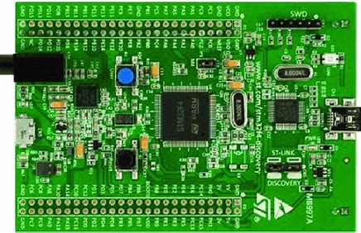

Fig. 4.1Microcontrolle

CHAPTER-5

HARDWARE COMPONENTS

5.1 Arduino Uno Microcontroller

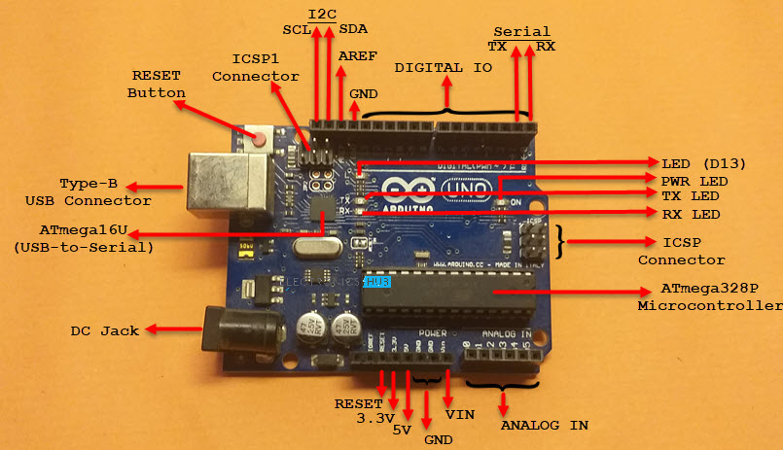

FIG:5.1: Arduino UNO
Arduino UNO is based on ATmega328P Microcontroller, an 8-bit AVR Architecture based MCU from ATMEL. Arduino UNO comes in two variants: one consists of a 28-pin DIP Microcontroller while the other consists of 32 lead Quad Flat Package Microcontroller.

5.1.1 What are Different Memories of Arduino UNO?
Strictly speaking, this is specific to the MCU i.e., ATmega328P, used on the Arduino UNO Board. There are three different memories available in ATmega328P. They are:
- 32 KB of Flash Memory
- 2 KB of SRAM
- 1 KB of EEPROM
- 0.5 KB of the Flash Memory is used by the bootloader code.

5.1.2 ARDUINO UNO BOARD:
The Arduino Uno is a microcontroller board based on the ATmega328. It has 14 digital input/output pins (of which 6 can be used as PWM outputs), 6 analog inputs, a 16 MHz ceramic resonator, a USB connection, a power jack, an ICSP header, and a reset button. It contains everything needed to support the microcontroller; simply connect it to a computer with a USB cable or power it with a AC-to-DC adapter or battery to get started.
Figure 5.1.2: Arduino uno board
The Uno differs from all preceding boards in that it does not use the FTDI USB-to-serial driver chip. Instead, it features the Atmega16U2 (Atmega8U2 up to version R2) programmed as a USB-to-serial converters.

5.1.3: Technical Specifications of Arduino UNO
As Arduino UNO is based on ATmega328P Microcontroller, the technical specifications of Arduino UNO are mostly related to the ATmega328P MCU. But none the less, let me give you a brief overview about some important specifications of Arduino UNO.

5.1.4 What are the Input and Output Pins of Arduino UNO?
Of the 32 pins available on the UNO board, 22 pins are associated with input and output. In that 14 pins (D0 to D13) are true digital IO pins, which can be configured as per you application using pinMode() , digitalWrite() and digitalRead() functions.
All these Digital IO pins are capable of sourcing or sinking 20mA of current (maximum 40mA is allowed). An additional feature of the Digital IO pins is the availability of internal pull-up resistor (which is not connected by default).
The value of the internal pull-up resistor will be in the range of 20KΩ to 50KΩ.
There are also 6 Analog Input Pins (A0 to A5). All the analog input pins provide a 10-bit resolution ADC feature, which can be read using analogRead() function.
An important point about Analog Input pins is that they can be configured as Digital IO pins, if required.
Digital IO pins 3, 5, 6, 9, 10 and 11 are capable of producing 8-bit PWM Signals. You can use analogWrite() function for this.

What Communication Interfaces are available on Arduino UNO?
Arduino UNO supports three different types of communication interfaces. They are:
- Serial
- I2C or I²C
- SPI
Perhaps the most common communication interface in the Arduino universe is the Serial Communication. In fact, the Arduino boards (UNO or Nano or Mega) are programmed using the serial communication.
Digital IO pins 0 and 1 are used as Serial RX and TX pins to receive and transmit serial data. These pins are connected to the serial pins of the on-board USB to Serial Converter IC.
Analog Input Pins A4 and A5 have alternative functions. They can be configured as SDA (A4) and SCL (A5) to support I2C or I²C or Two Wire Interface (TWI) communication.
The final communication interface is the SPI. Digital IO Pins 10, 11 12 and 13 can be configured as SPI pins SS, MOSI, MISO and SCK respectively.

5.1.5 : Pin Diagram & Description of an Arduino:

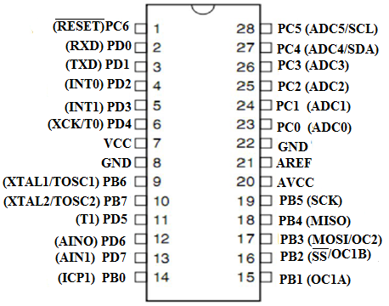
Fig:5.1.3: Pin diagram
For pin description of Arduino UNO, let us assume some basic numbering. Let the numbering begin with the RX Pin (D0). So, RX is Pin 1, TX is Pin 2, D2 is Pin 3 and so on.
On the other side, NC is Pin 19, IOREF is Pin 20 etc. Overall, there are 32 pins on the Arduino UNO Board.
With this information, let us now see the pin description of Arduino UNO.
Pin Number | Pin Name | Description | Alternative Functions
1 | RX / D0 | Digital IO Pin 0  Serial RX Pin | Generally used as RX
2 | TX / D1 | Digital IO Pin 1  Serial TX Pin | Generally used as TX
3 | D2 | Digital IO Pin 2
4 | D3 | Digital IO Pin 3 | Timer (OC2B)
5 | D4 | Digital IO Pin 4 | Timer (T0/XCK)
6 | D5 | Digital IO Pin 5 | Timer (OC0B/T1)
7 | D6 | Digital IO Pin 6
8 | D7 | Digital IO Pin 7
9 | D8 | Digital IO Pin 8 | Timer (CLK0/ICP1)
10 | D9 | Digital IO Pin 9 | Timer (OC1A)
11 | D10 | Digital IO Pin 10 | Timer (OC1B)
12 | D11 | Digital IO Pin 11 | SPI (MOSI) Timer (OC2A)
13 | D12 | Digital IO Pin 12 | SPI (MISO)
14 | D13 | Digital IO Pin 13 | SPI (SCK)
15 | GND | Ground
16 | AREF | Analog Reference
17 | SDA / D18 | Digital IO Pin 18 | I2C Data Pin
18 | SCL / D19 | Digital IO Pin 19 | I2C Clock Pin
19 | NC | Not Connected
20 | IOREF | Voltage Reference
21 | RESET | Reset (Active LOW)
22 | 3V3 | Power
23 | 5V | +5V Output from regulator or +5V regulated Input
24 | GND | Ground
25 | GND | Ground
26 | VIN | Unregulated Supply
27 | A0 | Analog Input 0 | Digital IO Pin 14
28 | A1 | Analog Input 1 | Digital IO Pin 15
29 | A2 | Analog Input 2 | Digital IO Pin 16
30 | A3 | Analog Input 3 | Digital IO Pin 17
31 | A4 | Analog Input 4 | Digital IO Pin 18 I2C (SDA)
32 | A5 | Analog Input 5 | Digital IO Pin 19 I2C (SCL)

5.2: Tilt Sensors:
A tilt sensor plays a crucial role in a Zigbee-based nearby vehicle accident alert system by detecting changes in the vehicle's inclination. In the event of an accident, a vehicle may roll over or tilt at an unusual angle, which the tilt sensor can accurately detect. When a vehicle tilts beyond a predetermined threshold, such as 45 degrees, the sensor sends a signal to the micro controller, confirming the possibility of a serious accident.
This is particularly useful in distinguishing between minor impacts and major accidents that require immediate attention. Additionally, in hilly terrains or inclined roads, the tilt sensor helps ensure that normal inclinations do not falsely trigger accident alerts. For two-wheeler, where falls are common, the tilt sensor becomes even more essential in identifying accidents effectively. When combined with other sensors like accelerometers and gyroscopes, it enhances the accuracy of accident detection, ensuring that alerts are sent only in genuine emergency situations. By integrating the tilt sensor with a Zigbee module, the system can quickly notify nearby vehicles about a detected accident, helping to prevent secondary collisions and improve road safety.
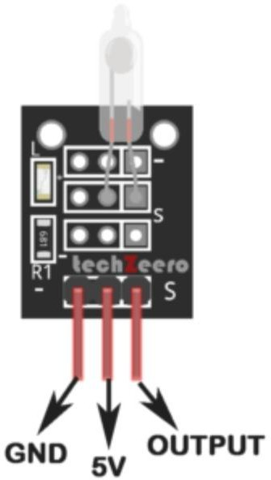
FIG:5.2.1:Tilt Sensor

5.2.1 :Components:
A tilt sensor is an electronic device used to detect changes in inclination or angular position. It typically consists of the following components:
1. Conductive Liquid or Ball Bearing
- Some tilt sensors use a small metal ball or conductive liquid inside a sealed chamber.
- When the sensor tilts, the ball or liquid moves, completing or breaking an electrical circuit.
2. Electrodes
- The sensor contains two or more electrodes that detect changes in connectivity.
- When the sensor tilts beyond a certain angle, the ball or liquid makes contact with specific electrodes, signaling a change in tilt position.
3. Casing/Enclosure
- A plastic or metal housing protects the internal components.
- The enclosure ensures durability and prevents environmental damage.

4.Resistors (in some models)
- Some tilt sensors include resistors to regulate current flow when the tilt is detected.
5. Mercury (in older models - not commonly used now)
- Older tilt sensors used mercury as the conductive material, but modern versions avoid it due to environmental concerns.

Types of Tilt Sensors
- Ball-Based Tilt Sensors (Uses a rolling metal ball to complete the circuit)
- Mercury Tilt Sensors (Uses mercury as a conductor, now rarely used)
- MEMS-Based Tilt Sensors (Uses microelectromechanical systems for high-precision tilt detection)
5.2.2: Working Principle:
- The tilt sensor is mounted on the vehicle and connected to a microcontroller (Arduino, ESP32, etc.).
- If the vehicle tilts beyond a critical angle (e.g., 45° for a car, 30° for a bike), the sensor triggers analert.
- The microcontroller processes the signal and sends an emergency message via Zigbee to nearbyvehicles.
- Additional sensors like accelerometers & gyroscopes help confirm if an accident has occurred toprevent false alerts.

5.2.3: Features of Tilt Sensors:
Applications:
- Detects vehicle rollovers and severe tilting.
- Identifies motorcycle falls for accident alerts.
- Assesses accident severity with other sensors.
- Prevents false alarms on slopes or uneven roads.
- Triggers Zigbee alerts for nearby vehicles.
- Supports emergency response with GPS/GSM ingratiate
Advantages:
- Simple & Compact → Small, lightweight, and easy to install.
- Quick Response → Detects tilt instantly for fast alerts.
- Low Power Consumption → Energy-efficient and ideal for battery-powered systems.
- Reliable & Durable → Works well in harsh conditions with minimal wear.
- Easy Integration → Compatible with micro-controllers like Arduino, ESP32, and Raspberry Pi.
- Accurate Detection → Effectively identifies rollovers, falls, and inclination changes.
- Cost-Effective → Affordable and widely available for various applications.
Limitations:
- Limited Angle Detection → Basic models detect only fixed tilt thresholds, not precise angles.
- Susceptible to Vibrations → External vibrations or rough terrains may cause false alerts.
- Binary Output in Basic Models → Simple sensors provide only ON/OFF signals without exact angle measurement.
- Environmental Sensitivity → Factors like temperature, humidity, and dust can affect performance.
- Not Suitable for High-Speed Motion → Accuracy may decrease in fast-moving vehicles.
- Requires Additional Sensors → Works best when combined with accelerometers and gyroscopes for accurate accident detection.

5.2.4:Implementation In the Project:
In the Zigbee-based nearby vehicle accident alert system, the tilt sensor plays a crucial role in detecting vehicle rollovers and falls. The sensor is mounted on the vehicle and connected to a micro-controller like Arduino or ESP32, which continuously monitors its output. When the vehicle tilts beyond a preset threshold (e.g., 45° for cars or 30° for bikes), the sensor triggers a signal indicating a possible accident. To avoid false alerts, the tilt sensor works alongside to confirm the accident’s severity. Once validated, the micro controller sends an accident alert via Zigbee to nearby vehicles, enabling them to take precautionary measures. The receiving vehicles can activate warning buzzers or display alerts to notify drivers about the accident ahead. Additionally, if integrated with GPS and GSM, the system can send real-time accident location data to emergency services for faster assistance. This implementation enhances road safety by ensuring quick alerts and reducing secondary collisions.

5.3: LCD (I2C):-
A liquid crystal display (LCD) is a thin, flat display device made up of any number of color or monochrome pixels arrayed in front of a light source or reflector. Each pixel consists of a column of liquid crystal molecules suspended between two transparent electrodes, and two polarizing filters, the axes of polarity of which are perpendicular to each other.
Without the liquid crystals between them, light passing through one would be blocked by the other. The liquid crystal twists the polarization of light entering one filter to allow it to pass through the other.
A program must interact with the outside world using input and output devices that communicate directly with a human being. One of the most common devices attached to an controller is an LCD display. Some of the most common LCDs connected to the controllers are 16X1, 16x2 and 20x2 displays. This means 16 characters per line by 1 line 16 characters per line by 2 lines and 20 characters per line by 2 lines, respectively.
Many microcontroller devices use 'smart LCD' displays to output visual information. LCD displays designed around LCD NT-C1611 module, are inexpensive, easy to use, and it is even possible to produce a readout using the 5X7 dots plus cursor of the display.
They have a standard ASCII set of characters and mathematical symbols. For an 8-bit data bus, the display requires a +5V supply plus 10 I/O lines (RS, RW, D7, D6, D5, D4, D3, D2, D1, D0).
For a 4-bit data bus it only requires the supply lines plus 6 extra lines (RS, RW, D7, D6, D5, D4).
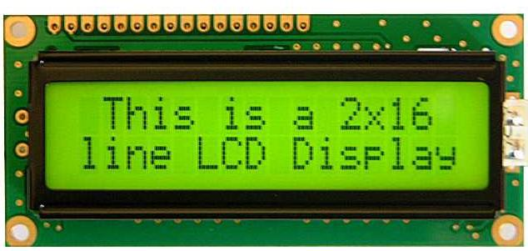
When the LCD display is not enabled, data lines are tri-state and they do not interfere with the operation of the microcontroller.
Fig 5.3.1: LCD Display
5.3.2: LCD WITH I2C:
The LCD (Liquid Crystal Display) module with I2C interface is utilized in this project to provide visual feedback and information display. It incorporates a standard HD44780-compatible LCD controlled through an I2C serial interface module, which reduces the number of GPIO pins required for operation, optimizing resource usage on the microcontroller.
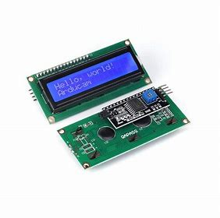
Fig:5.3.2 LCD WITH I2C
I2C Communication: Utilizes I2C (Inter-Integrated Circuit) protocol for communication, allowing easy interfacing with microcontrollers and reducing pin count requirements.
HD4480 Compatability:Compatible with HD44780 standard LCDs, providing ease of integration with existing libraries and codebases.
Backlight Control: Supports backlight control for visibility in different lighting conditions.
Character Display: Capable of displaying alphanumeric characters, symbols, and custom-defined characters.
Low Power Consumption: Designed for low power consumption, suitable for battery-operated applications.

LCD Pin Diagram:
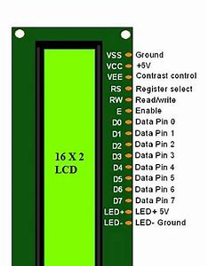

Fig.5.3.3 Pin Diagram of LCD
5.3.3 :Specifications:
Controller: HD44780-compatible LCD controller.
Interface: I2C (default address 0x3F or 0x27, configurable via solder jumpers).
Display Size: 16 characters x 2 lines (other configurations such as 20x4 also available).
Supply Voltage: Typically operates at 5V, compatible with 3.3V logic levels.
Operating Temperature: -20°C to +70°C.
Dimensions: Standard 80mm x 35mm x 11mm (L x W x H).
The LCD module is integrated into the project hardware by connecting the I2C lines to the microcontroller, ensuring proper power supply, and managing backlight control based on ambient lighting conditions. Initialization and control of the LCD are achieved through compatible libraries and functions, allowing dynamic text display and interface updates as per project requirements.
Applications:
- Embedded systems requiring visual feedback and user interaction.
- IoT (Internet of Things) devices for displaying sensor data and system status.
- Educational projects involving microcontroller interfacing and display technologies.

5.4: ZigBee module:

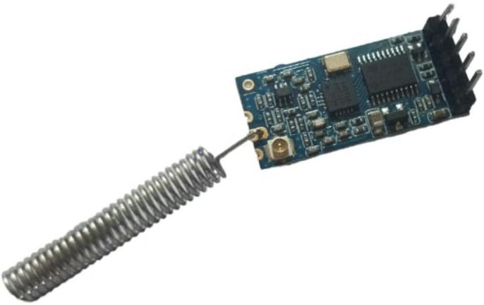

Fig: 5.4.1: ZigBee module

A Zigbee module is a wireless communication device that operates on the IEEE 802.15.4 standard, enabling low-power, short-range data transmission. It is widely used in IoT , automation, and safety applications due to its efficiency and reliability.

Role of Zigbee in the Accident Alert System;-
In a Zigbee-based nearby vehicle accident alert system, the Zigbee module enables wireless communication between vehicles to transmit accident alerts in real time.
5.4.1: Features:
- Low Power Consumption → Ideal for battery-operated devices and long-term use.
- Short-Range Wireless Communication → Operates within 10–100 meters, depending on obstacles.
- Mesh Networking Support → Expands coverage by allowing devices to relay signals.
- Reliable & Secure → Uses 128-bit AES encryption for data security.
- Fast Data Transmission → Ensures quick communication for real-time alerts.
- Low Latency → Provides near-instant responses, crucial for accident alert systems.
- Operates on IEEE 802.15.4 Standard → Ensures compatibility with various IoT and automation applications.
- Supports Multiple Devices → Can connect hundreds of nodes in a network.
- Cost-Effective → Cheaper than cellular-based communication like GSM.
5.4.2: Specifications:
- Standard → IEEE 802.15.4
- Frequency → 2.4 GHz, 868 MHz, 915 MHz
- Data Rate → Up to 250 kbps
- Range → 10–100 meters
- Network Topology → Star, Mesh, Tree
- Power Consumption → Low power, battery-friendly
- Security → 128-bit AES encryption
- Max Nodes → Supports up to 65,000 devices
- Latency → ~15 ms (Low latency)
- Voltage → Typically 3.3V or 5V

5.4.3:Usage:
- Accident Detection Communication → Sends alerts when a vehicle rollover or accident is detected.
- Vehicle-to-Vehicle (V2V) Alerting → Notifies nearby vehicles to take precautionary actions.
- Low-Power Wireless Transmission → Ensures continuous operation without draining battery power.
- Fast & Reliable Data Transfer → Provides quick alerts to prevent secondary collisions.
- Mesh Networking → Expands coverage by relaying alerts through multiple vehicles.
- Integration with Sensors → Works with tilt sensors and micro-controllers for accurate accident detection.
- Emergency Response Support → Can be linked with GPS/GSM to send accident location to emergency services.

5.5: JUMPER CABLES:
Jumper wires are simply wires that have connector pins at each end, allowing them to be used to connect two points to each other without soldering.
Types of Jumper Wires:
There are different types of jumper wires. Some have the same type of electrical connecter at both ends, while others have different connectors. Jumper wires typically come in three versions: male-to-male, male-to-female and female-to-female.

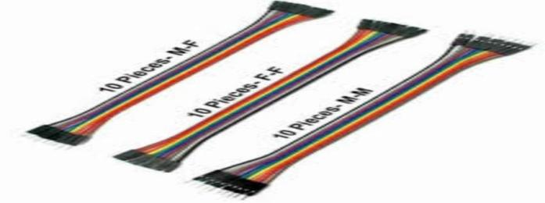
Fig 5.5.1: Jumper Cable
Solid tips – are used to connect on/with a breadboard or female header connector. The arrangement of the elements and ease of insertion on a breadboard allows increasing the mounting density of both components and jump wires without fear of short-circuits. The jump wires vary in size and color to distinguish the different working signals. Crocodile clips – are used, among other applications, to temporarily bridge sensors, buttons and other elements of prototypes with components or equipment that have arbitrary connectors, wires, screw.

5.6: Connecting wires:

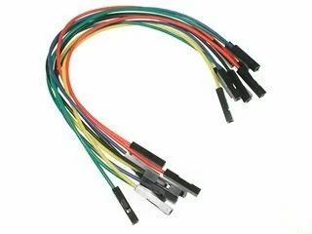
Fig: 5.6.1: Connecting wires
Connecting wires are essential components in electronics and electrical systems, used to establish electrical connections between various components, devices, or circuits. Here are the full details regarding connecting wires:

5.6.1: Types of Wires:
Stranded Wires: Composed of multiple thin strands of wire twisted or braided together.
They are flexible and ideal for applications where flexibility is needed, such as in cables for moving parts.
Solid Core Wires: Made from a single piece of wire, providing a more stable connection. They are commonly used in breadboard and permanent installations.
Shielded Wires: Have a protective outer layer (usually made of metal or foil) that reduces electromagnetic interference (EMI).
Twisted Pair Wires: Consist of two insulated wires twisted together, commonly used in Ethernet cables for data transmission.
Ribbon Cables: Multiple conductors laid parallel and flat, often used for internal connections within electronic devices.
2. Wire Gauge:
AWG (American Wire Gauge): The gauge indicates the diameter of the wire. Smaller gauge numbers represent thicker wires. Common gauges range from 30 AWG (very thin) to 10 AWG (thick).
Current Capacity: Larger gauge wires can carry more current without overheating. It's important to select a wire gauge that can handle the current load of your application to prevent overheating and potential damage.
3. Insulation and Jacket:
Insulation Material: Protects the conductor and prevents short circuits. Common materials include PVC (Polyvinyl Chloride), Teflon (PTFE), and silicone.
Jacket: Outer covering that provides additional protection and durability. Jackets can be made from PVC, rubber, or other materials depending on the application (e.g., indoor vs. outdoor use).
4. Connector Types:
Stripped and Tinned: Wire ends stripped of insulation and tinned with solder for easy connection.
Crimp Connectors: Used with crimping tools to attach wires to terminals or connectors.
Soldered Connections: Wires soldered directly to components or terminals.
Wire Nuts: Twist-on connectors used in household electrical wiring for joining multiple wires.
5.Application Areas:
Electronics: Internal connections on circuit boards, breadboarding, prototyping, etc.
Electrical Wiring: Household wiring, automotive wiring, industrial wiring.
Data Communication: Ethernet cables, USB cables, HDMI cables.
Power Transmission: High-voltage power lines, power cables.
6. Considerations:
Wire Length: Ensure the wire is long enough for the intended connection but not excessively long to avoid unnecessary clutter
Environmental Factors: Choose wires with appropriate insulation and jacketing for the environment where they will be used (e.g., temperature extremes, moisture).
Safety: Properly secure and insulate connections to prevent electrical hazards, short circuits, or fires.
Understanding the characteristics and types of connecting wires helps ensure safe and reliable electrical connections in various applications from small electronics to industrial installations.

5.7: POWER SUPPLY

A power supply is an essential component of electronic devices and systems that converts electrical energy from a source (like an outlet or battery) into a form suitable for powering various components. It provides the necessary voltage, current, and frequency required by the device function properly
.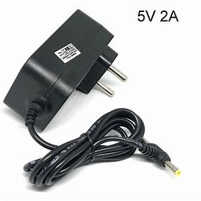

Fig 5.7: Adapter

5.8: GPS Module
A GPS (Global Positioning System) module is a device that receives signals from multiple GPS satellites and calculates its position, velocity, and time. It is widely used in navigation, tracking, and location-based applications.
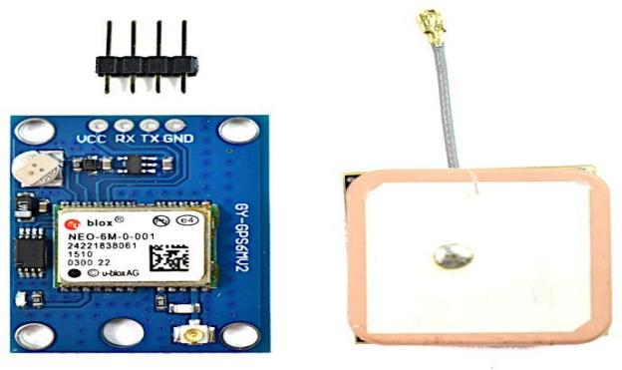
Fig 5.8: GPS Module
5.81. Working Principle of GPS Module
A GPS module works by receiving signals from at least four satellites in orbit. The module calculates its position using a technique called trilateration, which determines location based on the time delay between signal transmission and reception.
Steps in GPS Operation:
Satellite Signal Reception: The GPS module captures signals from multiple satellites.
Time Calculation: It calculates the time taken by the signal to travel from the satellite to the receiver.
position Calculation: Using trilateration, it determines the latitude, longitude, and altitude.
Data Output: The module sends this information to a microcontroller or computer via UART, I2C, or SPI communication.
5.8.2. Components of a GPS Module
A typical GPS module consists of the following parts:
a. GPS Receiver Chip:
The core of the module that processes satellite signals.
Popular chips include Ublox, MediaTek, Quectel, and SkyTraq.

b. Antenna:
Essential for receiving satellite signals.
Can be patch antennas (internal) or external active antennas (for better reception).
c. Communication Interface:
Common interfaces: UART (Serial), I2C, SPI, USB.
Used to connect with micro-controllers (Arduino, Raspberry Pi, etc.).
5.8.3. Types of GPS Modules
Standard GPS Modules: Provide basic location data (latitude, longitude, altitude). Example: Ublox NEO-6M.
GNSS Modules: Support multiple satellite systems (GPS, GLONASS, Galileo, BeiDou) for better accuracy.
Example: Ublox M8N.
RTK GPS Modules: High-precision GPS used in surveying and autonomous vehicles.
Example: Ublox ZED-F9P.

5.8.4. Applications of GPS Modules
- Navigation: Used in cars, aircraft, ships, and personal navigation devices.
- Tracking: Used in fleet management, pet tracking, and asset tracking.
- Surveying & Mapping: Used in geographical mapping, land surveying, and GIS applications.
- Autonomous Vehicles: Helps in robotics, drones, and self-driving cars.

5.8.5Advantages
- Provides accurate global positioning.
- Works in all weather conditions.
- No need for an internet connection.
- Low power consumption.

CHAPTER 6

WORKING

Working Principle:

uses the Zigbee wireless communication protocol to instantly notify nearby vehicles about an accident occurring in their vicinity,

Accident Detection: The tilt sensor continuously monitors the vehicle's orientation. If it detects a sudden and significant change in tilt angle, it sends a signal to the micro-controller.

Alert Triggering: The microcontroller processes the signal from the tilt sensor. Based on predefined thresholds, it determines if the change in tilt indicates an accident. If an accident is detected, the micro-controller triggers the alert system.

Message Transmission: The micro-controller sends an alert message to the Zigbee module. This message typically includes information about the accident, such as the location of the vehicle and the severity of the impact.

Alert Reception: The Zigbee module transmits the alert message wireless to nearby devices equipped with Zigbee receivers.

Action Taken: Upon receiving the alert message, the nearby devices can take appropriate action. For example, they might display a warning message to the driver, automatically contact emergency services, or even trigger other safety features like hazard lights.

6.1 BLOCK DIAGRAM

Transmeter End:-

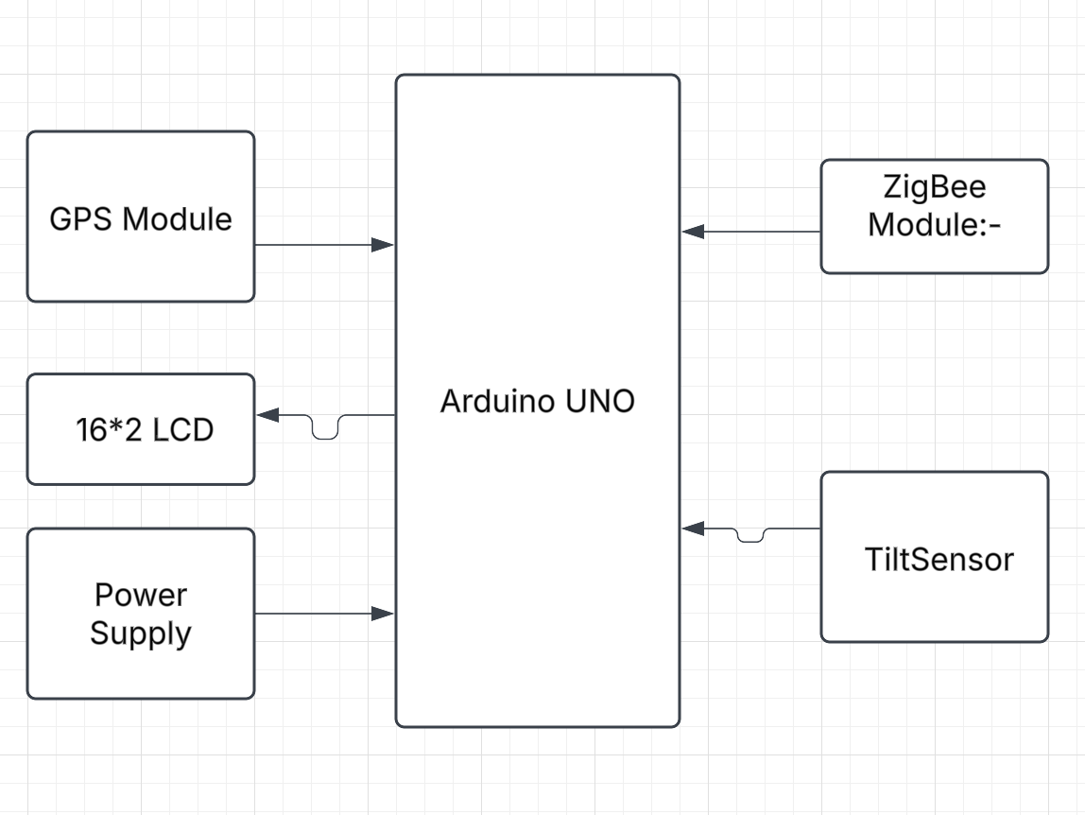

Receiver End:-

Fig 6.1. Block Diagram

6.2 SCHEMATIC DIAGRAM: 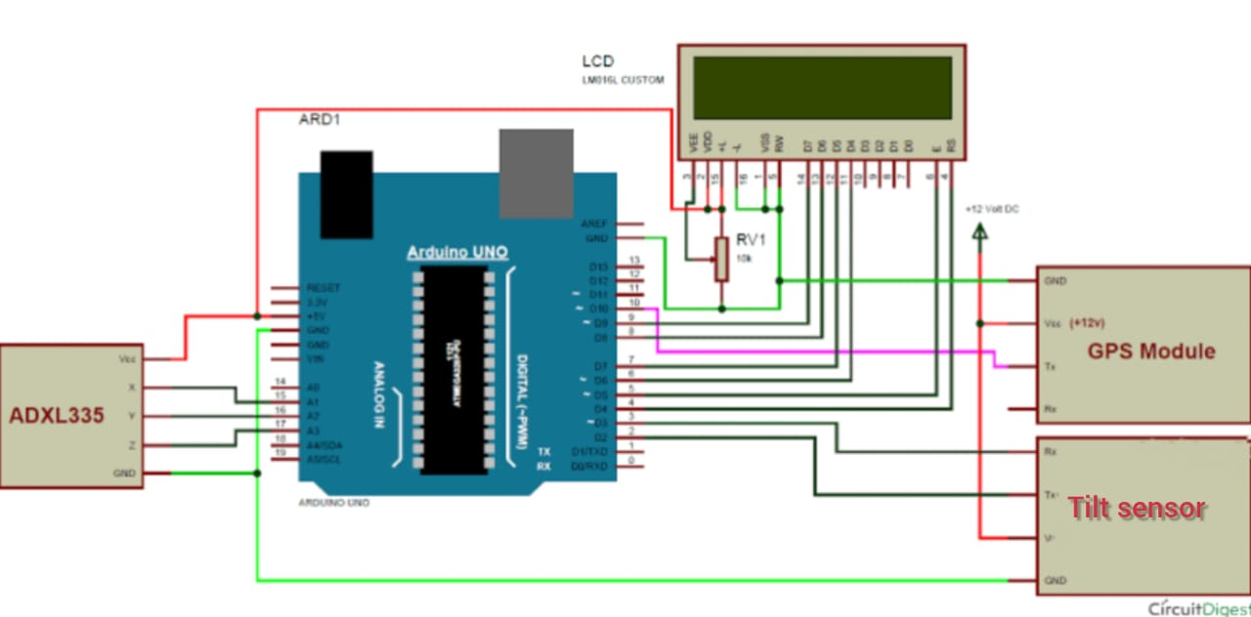

Fig 6.2. SCHEMATIC DIAGRAM

CHAPTER-7

SOFTWARE & CODING

7.1 Introduction to Arduino IDE:

Arduino is a prototype platform (open-source) based on an easy-to-use hardware and software. It consists of a circuit board, which can be programmed (referred to as a microcontroller) and a ready-made software called Arduino IDE (Integrated Development Environment), which is used to write and upload the computer code to the physical board.
The key features are:
- Arduino boards are able to read analog or digital input signals from different sensors and turn it into an output such as activating a motor, turning LED on/off, connect to the cloud and many other actions.
- You can control your board functions by sending a set of instructions to the microcontroller on the board via Arduino IDE (referred to as uploading software).
- Unlike most previous programmable circuit boards, Arduino does not need an extra piece of hardware (called a programmer) in order to load a new code onto the board. You can simply use a USB cable.
- Additionally, the Arduino IDE uses a simplified version of C++, making it easier to learn to program.
- Finally, Arduino provides a standard form factor that breaks the functions of the micro-controller into a more accessible package.
- After learning about the main parts of the Arduino UNO board, we are ready to learn how to set up the Arduino IDE. Once we learn this, we will be ready to upload our program on the Arduino board.

Arduino data types:

Data types in C refers to an extensive system used for declaring variables or functions of different types. The type of a variable determines how much space it occupies in the storage and how the bit pattern stored is interpreted.
The following table provides all the data types that you will use during Arduino programming.
Void:
The void keyword is used only in function declarations. It indicates that the function is expected to return no information to the function from which it was called.

Example:
Void Loop ( )
{
// rest of the code
}
Boolean:
A Boolean holds one of two values, true or false. Each Boolean variable occupies one byte of memory.
Char: A data type that takes up one byte of memory that stores a character value. Character literals are written in single quotes like this: 'A' and for multiple characters, strings use double quotes: "ABC".
However, characters are stored as numbers. You can see the specific encoding in the ASCII chart. This means that it is possible to do arithmetic operations on characters, in which the ASCII value of the character is used. For example, 'A' + 1 has the value 66, since the ASCII value of the capital letter A is 65.
Unsigned char:
Unsigned char is an unsigned data type that occupies one byte of memory. The unsigned char data type encodes numbers from 0 to 255.
Byte:
A byte stores an 8-bit unsigned number, from 0 to 255.
int:
Integers are the primary data-type for number storage. int stores a 16-bit (2-byte) value. This yields a range of -32,768 to 32,767 (minimum value of -2^15 and a maximum value of (2^15) - 1).
The int size varies from board to board. On the Arduino Due, for example, an int stores a 32-bit (4-byte) value.
Unsigned int:
Unsigned ints (unsigned integers) are the same as int in the way that they store a 2 byte value. Instead of storing negative numbers, however, they only store positive values, yielding a useful range of 0 to 65,535 (2^16) - 1).
Word:
On the Uno and other ATMEGA based boards, a word stores a 16-bit unsigned number. On the Due and Zero, it stores a 32-bit unsigned number.
Long:
Long variables are extended size variables for number storage, and store 32 bits (4 bytes), from 2,147,483,648 to 2,147,483,647.

Unsigned long: Unsigned long variables are extended size variables for number storage and store 32 bits (4 bytes). Unlike standard longs, unsigned longs will not store negative numbers, making their range from 0 to 4,294,967,295 (2^32 - 1).
Short:
A short is a 16-bit data-type. On all Arduinos (ATMega and ARM based), a short stores a 16-bit (2-byte) value. This yields a range of -32,768 to 32,767 (minimum value of -2^15 and a maximum value of (2^15) - 1).
Float:
Data type for floating-point number is a number that has a decimal point. Floating-point numbers are often used to approximate the analog and continuous values because they have greater resolution than integers.
Floating-point numbers can be as large as 3.4028235E+38 and as low as 3.4028235E+38. They are stored as 32 bits (4 bytes) of information.
Double:
On the Uno and other ATMEGA based boards, Double precision floating-point number occupies four bytes. That is, the double implementation is exactly the same as the float, with no gain in precision. On the Arduino Due, doubles have 8-byte (64 bit) precision.
In this section, we will learn in easy steps, how to set up the Arduino IDE on our computer and prepare the board to receive the program via USB cable.
Step 1: First you must have your Arduino board (you can choose your favorite board) and a USB cable. In case you use Arduino UNO, Arduino Duemilanove, Nano, Arduino Mega2560, or Diecimila, you will need a standard USB cable (A plug to B plug), the kind you would connect to a USB printer as shown in the following image.

Figure 7.1: USB Cable
Step 2: Download Arduino IDE Software.
You can get different versions of Arduino IDE from the Download page on the Arduino Official website. You must select your software, which is compatible with your operating system (Windows, IOS, or Linux). After your file download is complete, unzip the file.

Step 3: Power up your board.
The Arduino Uno, Mega, Duemilanove and Arduino Nano automatically draw power from either, the USB connection to the computer or an external power supply. If you are using an Arduino Diecimila, you have to make sure that the board is configured to draw power from the USB
connection. The power source is selected with a jumper, a small piece of plastic that fits onto two of the three pins between the USB and power jacks. Check that it is on the two pins closest to the USB port. Connect the Arduino board to your computer using the USB cable. The green power LED (labeled PWR) should glow.

Step 4: Launch Arduino IDE.
After your Arduino IDE software is downloaded, you need to unzip the folder. Inside the folder, you can find the application icon with an infinity label (application.exe). Double click the icon to start the IDE.

Step 5: Open your first project.
Once the software starts, you have two options:
- Create a new project.

- Open an existing project example.

To create a new project, select File --> New. To open

To open an existing project example, select File -> Example -> Basics -> Blink.

Here, we are selecting just one of the examples with the name Blink. It turns the LED on and off with some time delay. You can select any other example from the list.

Step 6: Select your Arduino board.
To avoid any error while uploading your program to the board, you must select the correct Arduino board
name, which matches with the board connected to your computer.
Go to Tools -> Board and select your board

Here, we have selected Arduino Uno board according to our tutorial, but you must select the name matching the board that you are using
Step 7: Select your serial port:
Select the serial device of the Arduino board. Go to Tools ->Serial Port menu. This is likely to be COM3 or higher (COM1 and COM2 are usually reserved for hardware serial ports). To find out, you can disconnect your Arduino board and re-open the menu, the entry that disappears should be of the Arduino board. Reconnect the board and select that serial port.
Step 8: Upload the program to your board: Before explaining how we can upload our program to the board, we must demonstrate the function of each symbol appearing in the Arduino IDE toolbar.

A- Used to check if there is any compilation error.
B- Used to upload a program to the Arduino board.
C- Shortcut used to create a new sketch.
D- Used to directly open one of the example sketch.
E- Used to save your sketch.
F- Serial monitor used to receive serial data from the board and send the serial data to the board.
Now, simply click the "Upload" button in the environment. Wait a few seconds; you will see the RX and TX LEDs on the board, flashing. If the upload is successful, the message "Done uploading" will appear in the status bar.
Note: If you have an Arduino Mini, NG, or other board, you need to press the reset button physically on the board, immediately before clicking the upload button on the Arduino Software.
Arduino programming structure
In this chapter, we will study in depth, the Arduino program structure and we will learn more new terminologies used in the Arduino world. The Arduino software is open-source. The source code for the Java environment is released under the GPL and the C/C++ microcontroller libraries are under the LGPL.
Sketch: The first new terminology is the Arduino program called “sketch”.
Structure
Arduino programs can be divided in three main parts: Structure, Values (variables and constants), and Functions. In this tutorial, we will learn about the Arduino software program, step by step, and how we can write the program without any syntax or compilation error.
Let us start with the Structure. Software structure consist of two main functions:
- Setup( ) function
- Loop( ) function

Void setup ()
{

}

PURPOSE:
The setup() function is called when a sketch starts. Use it to initialize the variables, pin modes, start using libraries, etc. The setup function will only run once, after each power up or reset of the Arduino board.
INPUT
OUTPUT
RETURN
Void Loop ()
{

}

CHAPTER-8

RESULT AND APPLICATIONS

RESULT:

Vehicle-1

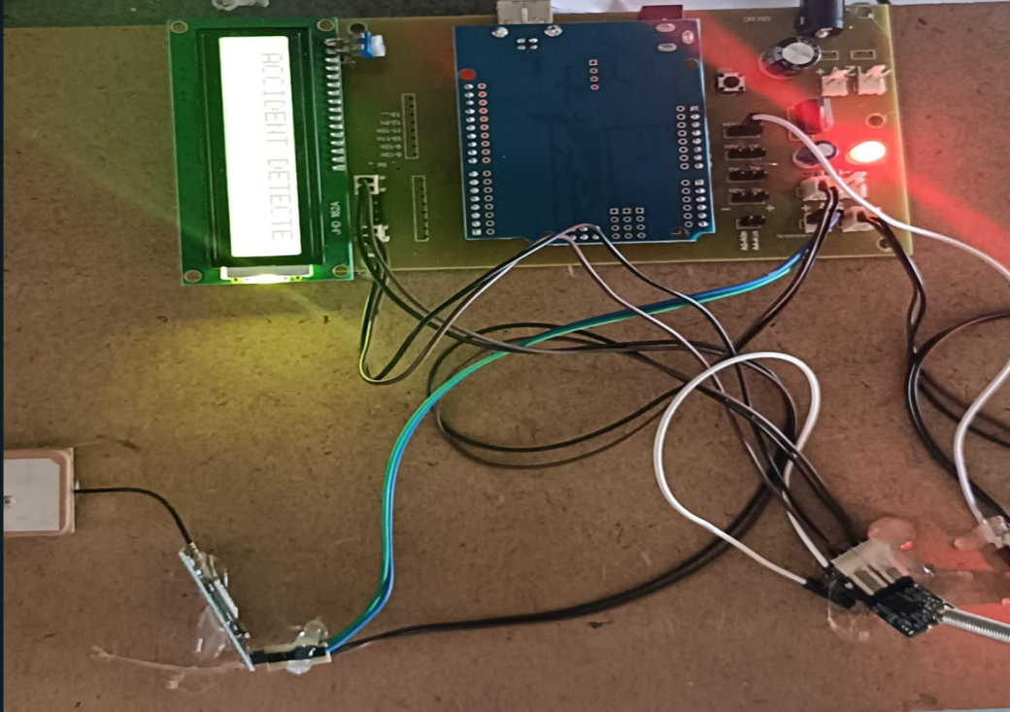

vehicle-2

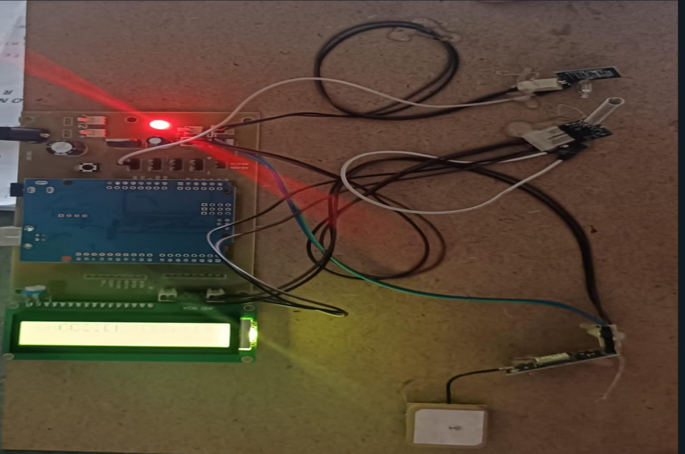

CHAPTER -9

ADVANTAGES & APPLICATIONS

9.1: Advantages of Zigbee-based Vehicle Accident Alert System:
Wireless Communication:
Uses Zigbee for reliable, short-range communication between vehicles.
Eliminates the need for wired connections, making installation easier.
Low Power Consumption:
Zigbee operates on low power, making it energy-efficient and ideal for battery-powered systems.
Real-Time Alerts:
Sends instant alerts to nearby vehicles, helping to prevent secondary collisions.
Mesh Networking Support :
Zigbee’s mesh topology ensures communication even if a direct link between two vehicles is unavailable.
Cost-Effective:
Cheaper than cellular-based accident alert systems (like GSM or IoT-based solutions).
Works Without Internet :
Unlike GPS or GSM systems, Zigbee does not require an internet connection, making it useful in remote areas.
Scalability:
Can support multiple vehicles in the same network, making it scalable for traffic safety systems.
Easy Integration:
Can be integrated with other sensors (like accelerometers, gyroscopes, or gas sensors) to improve accident detection accuracy.

9.2: Applications of Zigbee based nearby vehicle accident alert system:
Vehicle-to-Vehicle (V2V) Communication:
Alerts nearby vehicles about an accident, helping to prevent chain collisions.
Intelligent Transportation Systems (ITS):
Can be integrated into smart traffic management to enhance road safety.
Emergency Response Systems:
Sends accident alerts to emergency services for quicker rescue operations.
Fleet Management:
Helps logistics and transport companies monitor vehicle accidents in real-time.
Autonomous Vehicles:
Used in self-driving cars for detecting nearby accidents and adjusting routes.
Smart Highways:
Zigbee-based systems can be used in highway monitoring to detect accidents and inform approaching vehicles.
Motorbike and Bicycle Safety:
Can be implemented in two-wheelers to alert nearby vehicles in case of accidents.
Construction & Mining Vehicles:
Used in heavy machinery to prevent accidents in work zones.

CHAPTER-10
CONCLUSION AND FUTURE SCOPE

10.1: CONCLUSION:
A Zigbee-based Vehicle Accident Alert System is a cost-effective, energy-efficient, and real-time solution for enhancing road safety. By leveraging Zigbee’s low-power, wireless communication, vehicles can instantly alert nearby drivers about accidents, reducing the risk of secondary collisions.
This system is particularly useful in smart transportation, fleet management, and emergency response, where quick accident detection can save lives. Additionally, its mesh networking capability ensures reliable communication even in complex road environments.
Overall, integrating Zigbee technology with tilt sensors and microcontrollers can significantly improve accident response times and traffic safety, making roads safer for everyone. 🚗💡🚦
Would you like assistance in designing the system further? 😊
10.2: FUTURE SCOPE:
GPS Integration – Enables real-time location tracking of accidents.
AI & Machine Learning – Predicts accidents and reduces false alarms.
Cloud & IoT Connectivity – Stores accident data for analysis and emergency response.
Multi-Sensor Fusion – Combines accelerometers, gyroscopes, and gas sensors for accurate detection.
Extended Zigbee Network – Uses repeaters or hybrid Zigbee + LoRa for long-range communication.
Vehicle-to-Infrastructure (V2I) Communication – Alerts traffic signals and road signs.
Mobile App Integration – Sends accident alerts to drivers, emergency responders, and families.
Autonomous Vehicle Support – Helps self-driving cars detect and avoid accident zones.
Government & Legal Adoption – Can be made mandatory for improved road safety.
REFERENCES:
Books & Research Papers:
Zigbee wireless networking by Drew Gislason – Covers Zigbee communication principles.
Vehicle to Vehicle Communication Technologies– IEEE research papers on wireless vehicle communication.
IEEE & Research Journals:
IEEE Xplore: Papers on Zigbee-based accident alert systems & V2V communication.
Springer & Elsevier: Studies on IoT & Zigbee applications in road safety.
Websites & Technical Resources:
www.digi.com – Official Zigbee module documentation (XBee S2C, XBee Pro).
www.sciencedirect.com – Journals on smart accident detection and vehicle communication.
www.arduino.cc – Interfacing Zigbee with Arduino for wireless alerts.
Government & Safety Regulations:
NHTSA (National Highway Traffic Safety Administration) – Studies on V2V communication.
BIS & ISO Standards – Guidelines for vehicle safety communication systems.

CODE:
#include <SoftwareSerial.h>
#include <LiquidCrystal.h>

const int rs = 13, en = 12, d4 = 11, d5 = 10, d6 = 9, d7 = 8;
LiquidCrystal lcd(rs, en, d4, d5, d6, d7);

// SoftwareSerial for HC-12 Communication
//SoftwareSerial myserial(2, 3);

// SoftwareSerial for GPS Module
SoftwareSerial gps(7, 6);

int tilt = A0;
unsigned long previousMillis = 0;
const long sensorInterval = 5000; // Read sensors every 300ms

String latitude = "17.729922510455822";
String longitude = "79.19878222308927";

void scrollText(String text) {
text = " " + text + " ";
int textLength = text.length();
for (int i = 0; i < textLength + 16; i++) {
lcd.clear();
lcd.setCursor(0, 0);
lcd.print(text.substring(i, i + 16));
delay(150);
}
}

void setup() {
pinMode(tilt, INPUT);
Serial.begin(9600);
//myserial.begin(9600);
gps.begin(9600);
lcd.begin(16, 2);

lcd.print("VEHICLE TO VEHICLE");
lcd.setCursor(0, 1);
lcd.print("COMMUNICATION");
delay(2000);
}

void loop() {
unsigned long currentMillis = millis();

// Non-blocking sensor reading
if (currentMillis - previousMillis >= sensorInterval) {
previousMillis = currentMillis;
getGPSData(); // Update GPS coordinates periodically
}

// Check for incoming HC-12 data
if (Serial.available()) {
String message = Serial.readString();
// Serial.println("Received: " + message);
lcd.clear();
scrollText(message);
}

// Accident detection
if (digitalRead(tilt) == LOW) {
lcd.clear();
lcd.print("ACCIDENT DETECTED");
Serial.println("ALERT: VEHICLE ACCIDENT");

String accidentMessage = "ALERT: VEHICLE ACCIDENT\n";
accidentMessage += "Location: https://maps.google.com/?q=" + latitude + "," + longitude;

Serial.println(accidentMessage);
// myserial.println(accidentMessage);

delay(5000); // Avoid repeated messages
}
}

void getGPSData() {
while (gps.available()) {
String gpsData = gps.readStringUntil('\n');

if (gpsData.startsWith("$GPGGA")) { // Look for GPGGA sentences
String data[15];
int index = 0;

for (int i = 0; i < gpsData.length(); i++) {
if (gpsData[i] == ',') index++;
else data[index] += gpsData[i];
}

if (data[2] != "" && data[4] != "") { // If valid coordinates
latitude = convertToDecimal(data[2]);
longitude = convertToDecimal(data[4]);
}
}
}
}

String convertToDecimal(String nmea) {
if (nmea.length() < 6) return "0.000000"; // Return default if invalid

String degrees = nmea.substring(0, 2);
String minutes = nmea.substring(2);
float decimal = degrees.toInt() + (minutes.toFloat() / 60.0);

return String(decimal, 6); // Return 6 decimal places
}

